Refuges Speaker and Bios:
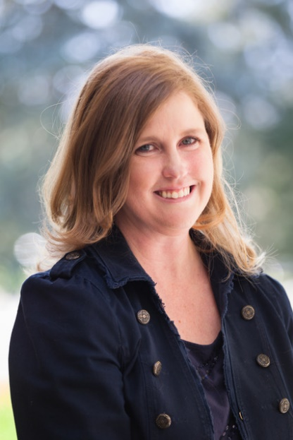
"The Politics of Refuge and Ethos of Care in Refugee Resettlement”
Professor Emily Skop, PhD, Geography and Environmental Studies. Emily Skop is a Professor in the Department of Geography and Environment Studies at UCCS. Professor Skop’s scholarship explores global migration and its consequences with a particular focus on refugee resettlement and placemaking. She also broadly examines the multiple ways in which scale is utilized as a concept to create legacies of advantage and disadvantage, in a variety of contexts, including academia. Professor Skop has built a significant research record, including a book titled The Immigration and Settlement of Asian Indians, and over fifty peer-reviewed book chapters and research articles. In addition, she maintains ongoing academic and service interests in the discipline of geography, with a focus on broadening participation in higher education using an ethos of care. As evidence of her continued contributions, Professor Skop was recently co-awarded a $1.1 million NSF ADVANCE grant called Project CREST: Changing Research Experiences, Structures, and (in)Tolerance through the Adaptation of Promising Equity Practices to positively impact the research experiences and productivity of women- and minority-identified faculty at UCCS. Professor Skop was also named a 2019-2020 University of Colorado Excellence in Leadership Fellow, awarded the 2018 Distinguished Scholar Award in Ethnic Geography from the American Association of Geographers, as well as the 2017 UCCS Faculty Award for Outstanding Contribution to Diversity and Inclusiveness.

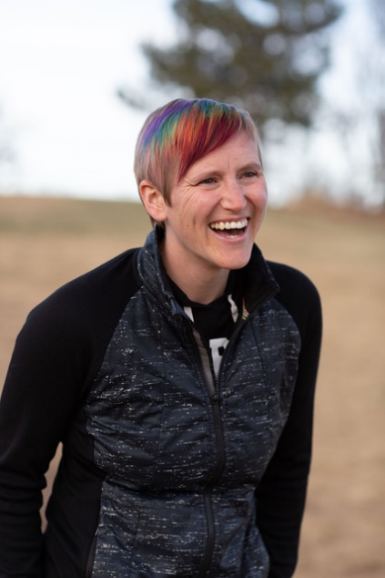
“Global Communities and Obligations to Refugees”
Associate Professor Jennifer Kling, PhD, Philosophy. Jennifer Kling is Associate Professor of Philosophy and Director of the Center for Legal Studies at the University of Colorado, Colorado Springs. Her research focuses on social and political philosophy, particularly issues in war and peace, protest, feminism, and philosophy of race. She is the author of Can War Be Justified? A Debate (with Andrew Fiala, Routledge 2023), Racist, Not Racist, Antiracist: Language and the Dynamic Disaster of American Racism (with Leland Harper, Lexington 2022), The Philosophy of Protest: Fighting for Justice without Going to War (with Megan Mitchell, Rowman & Littlefield 2021), War Refugees: Risk, Justice, and Moral Responsibility (Lexington 2019), and numerous articles in academic journals and edited collections. She is the Executive Director of Concerned Philosophers for Peace, the largest, most active organization of professional philosophers in North America involved in the analysis of the causes of war and prospects for peace.

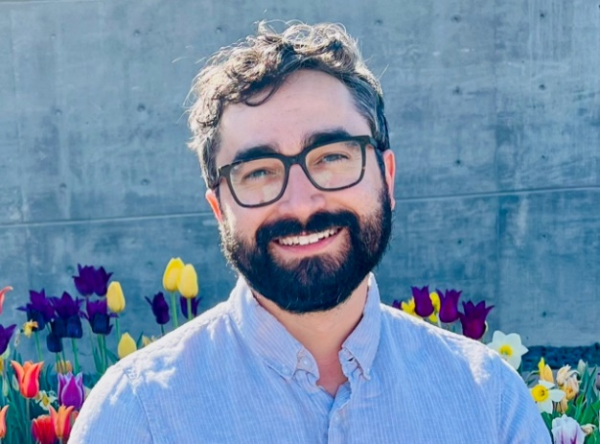
Refuge Crisis: Welcoming, Excluding, and Creating Refugees in the 19th and 20th Century United States”
Assistant Professor Evan Taparata, PhD, History. Evan Taparata is an assistant professor in the History Department at the University of Colorado, Colorado Springs. His research and teaching focus on migration, empire, and law in the 19th and 20th century United States. He is currently exploring these themes in his first book project, tentatively titled Refuge Crisis: The Making of the United States Refugee Regime, which examines how settler colonialism, slavery, and exclusionary immigration law shaped U.S. refugee policies in the 19th and early 20th century U.S. Before joining the History faculty at UCCS he held postdoctoral fellowships at Harvard University’s Charles Warren Center for Studies in American History and the University of Pennsylvania’s Andrea Mitchell Center for the Study of Democracy. In addition to his research and teaching, he has participated in several collaborative public-facing projects, including the Migration Scholar Collaborative, the #ImmigrationSyllabus and the Humanities Action Lab’s “States of Incarceration” initiative, and is a coeditor of AbusablePast.org, the online extension of the Radical History Review.

